

**NOVEMBER 2022**

**SPRINT 2**

## Report by:

## THARANI

## PAVITHRA SOWMIYA PRIYADHARSHINI

**LITRATURE SURVEY**

Litrature Survey Link Authors Year



[**https://www.researchgate.net/publication/354271614_**](https://www.researchgate.net/publication/354271614_Waste_Management_Technology_for_Sustainable_Agriculture_Waste_Management_Waste_Management_Technology_for_Sustainable_Agriculture)

[**Waste_Management_Technology_for_Sustainable_Agricul**](https://www.researchgate.net/publication/354271614_Waste_Management_Technology_for_Sustainable_Agriculture_Waste_Management_Waste_Management_Technology_for_Sustainable_Agriculture)

[**ture_Waste_Management_Waste_Management_Technolo gy_for_Sustainable_Agriculture**](https://www.researchgate.net/publication/354271614_Waste_Management_Technology_for_Sustainable_Agriculture_Waste_Management_Waste_Management_Technology_for_Sustainable_Agriculture)

[**https://ieeexplore.ieee.org/document/8515871**](https://ieeexplore.ieee.org/document/8515871)

[**https://ieeexplore.ieee.org/abstract/document/80796**](https://ieeexplore.ieee.org/document/8515871)

[**23**](https://ieeexplore.ieee.org/document/8515871)

[**https://www.researchgate.net/publication/332954030**](https://ieeexplore.ieee.org/document/8515871)

[**_An_Automated_Machine_Learning_Approach_for_Smart**](https://ieeexplore.ieee.org/document/8515871)

[**_Waste_Management_Systems**](https://ieeexplore.ieee.org/document/8515871)

**Muzaﬀar Ahmad Bhat , A. Wani Adil , Yaqoob Lone**

[**Mohammed Adam** , **Mohammed**](https://ieeexplore.ieee.org/author/37073132200)[**Elnour Okasha , Omer Mohammed Tawfeeq** ,](https://ieeexplore.ieee.org/author/37086500384) [**Bakri Nasreldeen**](https://ieeexplore.ieee.org/author/37086497282)

[**Supratim Auddy**](https://ieeexplore.ieee.org/author/37086499447) , [**Shubham Kumar**](https://ieeexplore.ieee.org/author/37086217921) ,

[**Amrendra Kumar Singh ,Debmalya**](https://ieeexplore.ieee.org/author/37088744823)

[**Ghosh**](https://ieeexplore.ieee.org/author/37088744823)

[**Denis Kleyko**](https://ieeexplore.ieee.org/author/37086499447) , [**Fredrik Blomstedt**](https://www.researchgate.net/profile/Fredrik-Blomstedt)

,[**David Rutqvist**](https://www.researchgate.net/scientific-contributions/David-Rutqvist-2157022182)

**2021**

**2018**

**2017**

**2019**

**LITRATURE SURVEY**

Metropolitan city waste management system Literature review:

In the recent spans of years, Urbanization has inflated terribly nice in size and there's a rise in waste production. Waste management has been a typical issue to be thought of. during this paper, sensible bin is constructed with ARM microcontroller that is interfaced With UART and IR sensors. IR sensors square measure placed at each ends of trash bin. They work under AND operation. When the dust bin is filled message will be sent to the respective mobile displaying “Garbage is filled”. It ceaselessly alerts the specified authority till the rubbish within the garbage can is press. Once the garbage can is press, individuals will recycle the garbage can. Once these dustbins are enforced on an outsized scale, by substitution ancient bins, waste will be re-used expeditiously and avoids gratuitous lumping of wastes on road aspect. Foul smell from these rotten wastes that remained untreated for while, because of neglectfulness of authorities and public could cause sturdy issues. Breeding of insects and mosquitoes will produce nuisance around promoting unclean atmosphere. this might even cause dreadful diseases.

Pros:

Advancement of smart city system.

Effective management of the city waste helps people life style to improve

Making the garbage system an IoT application opens path to a lot of different opportunities

Hands on Device system for garbage system helps to have a more detailed update on the disposal system. Applications:

Can be implemented in highly trafficking system

Apartment based lifestyle has a huge requirement for this kind of system Helps city people to have a update on garbage system

Hardware Setup:

The implementation of the smart garbage monitoring system is done by following the design approach as discussed earlier. The program is based on the C-compiler based IOT technique is loaded into the ARM micro-controller. The ARM 7 LPC 2148 micro-controller is used and the compiler lab code written can be ported on to the micro-controller using Code Composer Studio. The LCD module is connected onto the ARM 7 LPC 2148 kit, to deliver the latitudinal and longitudinal positions thus developed is also sent the respective mobile. ARM micro-controller is high speed ant is d based on RISC architecture. It has 64 bit micro-processor. It has reduced complexity, less power consumption and smaller size. The 16*2 LCD module can display 224 symbols is interfaced with LPC 2148 kit, it is helpful in providing user interface as well as for debugging purpose. LCD modules can display textual information as well as numerical information to user. The 16 by 2 LCD interface supports both 4 bit and 8bit. and facilitates to adjust. It has 16 characters per line by 2 lines.

That is each line displays 16 characters in 2 lines. Also the GSM module is interfaced with the UART, C program to send a message from LPC 2148 to mobile through GSM.

Conclusion:

The project titled “Smart garbage monitoring system “is aimed at implementing a safe and clean

environment. Our proposed reward based intelligent garbage based system when implemented on a large scale and in the long run can get high satisfying outputs. By implementing this system of garbage disposal and collection we can reduce the pollution cost by the stinking garbage that we come across along the road paving way for clean environment also not only the world is made clean but also people are rewarded for the help. This robotization of waste additionally diminishes the human exertion and therefore the expense of entire procedure. This framework can be executed at wherever easily and inside sensible measure of time.

Our work is little however a productive advances for working of a fantasy city with a clean and an extremely sound condition. With support from the administration we trust that our proposed framework when actualized will give exceptional returns.

# PROBLEM STATMENT

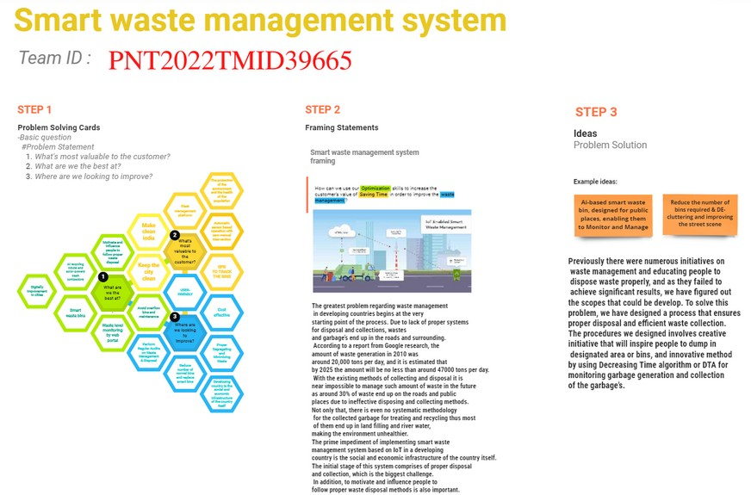

**BRAIN STORM**

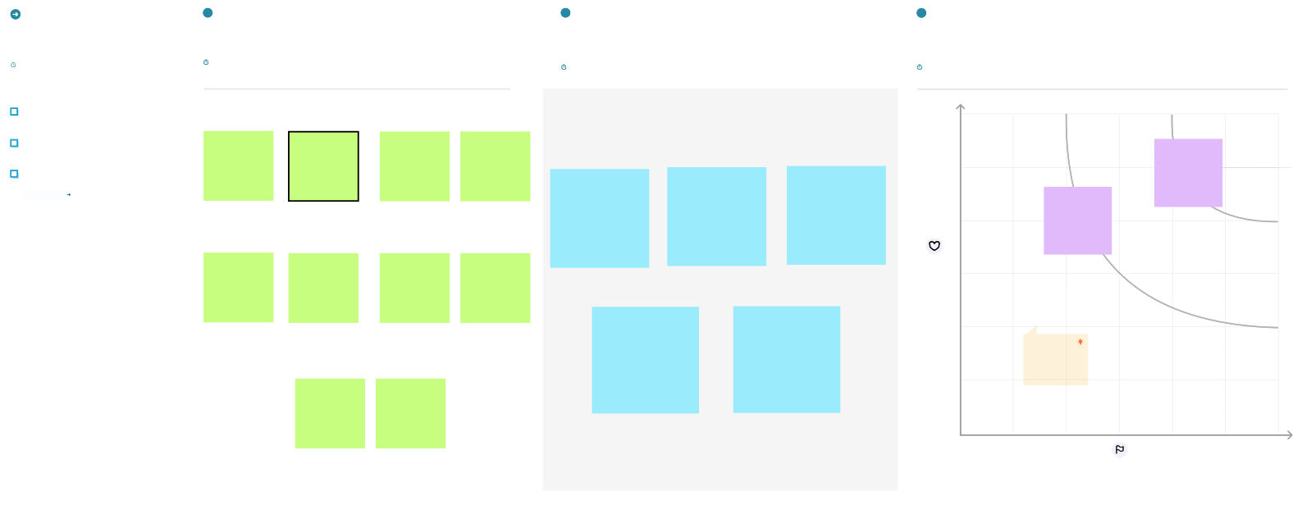

**Before you collaborate**

|  |  |  |  |
| --- | --- | --- | --- |
| **1**  **Brainstorm**  Write down any ideas that come to mind that address your problem statement.  **10 minutes**  **Gopi**  The proposed system Placing  would be able to  automate the solid waste Ultrasonic  monitoring process and sensor to  management of the  overall collection detect level  process using IOT  (Internet of Things). of bins  **Saravana**  Load cell on Place  bottom of b Arduion ft  bins oard at le  side of bins  **Surya**  when bins fill alert message to the authorized person | **Prakash**  Enable GPS Waste function to generation locate bins analysis to  easier understand  cities usages  **Kamlesh**  Visual fill using by GSM in bins achieve  status wireless  indicators on communication top of bins with bins and managing center  solar panels for power supply for IOT devices | **2**  **Group ideas**  Take turns sharing your ideas while clustering similar or related notes as you go. Once all sticky notes have been grouped, give each cluster a sentence-like label. If a cluster is bigger than six sticky notes, try and see if you and break it up into smaller sub-groups.  **20 minutes** | **3** |
| **Prioritize** |
| Your team should all be on the same page about what's |
| important moving forward. Place your ideas on this grid to |
| determine which ideas are important and which are feasible. |
| **20 minutes** |
| Smart Transparency Optimized garbage and sustainable trash  solution than  maintenance normal garbage collection server bins route  Collect only IOT alert  degradable authorized  and non- person when  degradable bins going to wastes fill | Waste |
| generation |
| analysis to |
| understand |
| Raspberry-pi cities usages |
| with ultrasonic, |
| GPS, Load cell, |
| are |
| configured |
| **Importance** |
| If each of these |
|  |
|  |
|  |
|  |
|  |
| impact? |
| **TIP** |
| Participants can use their |
| cursors to point at where |
| sticky notes should go on |
| the grid. The facilitator can |
| confirm the spot by using |
| the laser pointer holding the |
| **H key** on the keyboard. |
|  |
| **Feasibility** |
| Regardless of their importance, which tasks are more |
| feasible than others? (Cost, time, effort, complexity, etc.) |
|  |  |

A little bit of preparation goes a long way with this session. Here’s what you need to do to get going.

**10 minutes**

**TEAM ID:** PNT2022TMID39665

**A Team gathering**

Define who should participate in the session and send an invite. Share relevant information or pre-work ahead.

**B Set the goal**

Think about the problem you'll be focusing on solving in the brainstorming session.

**C Learn how to use the facilitation tools**

Use the Facilitation Superpowers to run a happy and productive session.

[**Open article**](https://support.mural.co/en/articles/2113740-facilitation-superpowers)